**MILK POWDER**

**HERO**

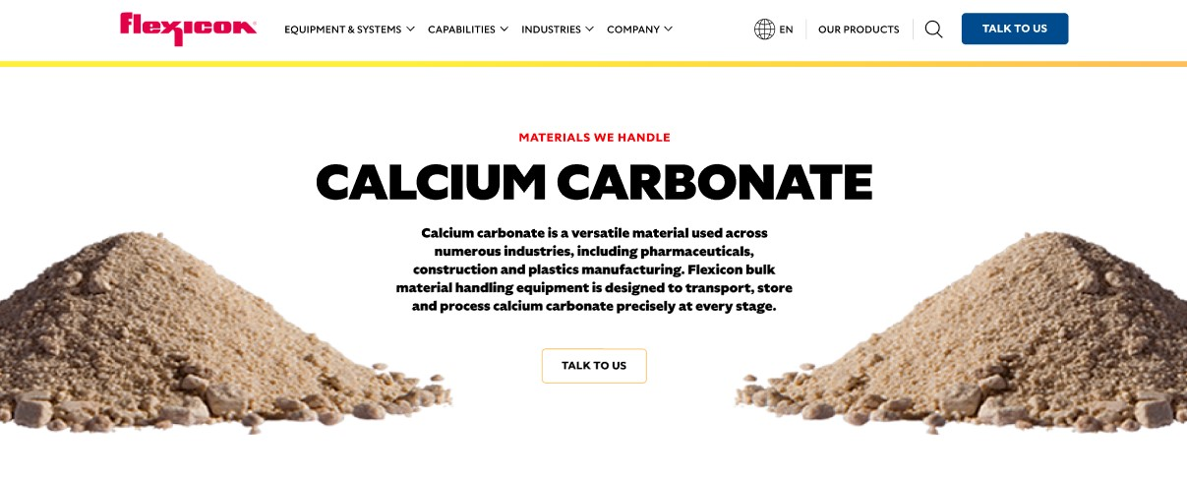

Milk powder is a versatile dairy product made by removing water from milk, which extends shelf life and reduces the potential for microbial growth. It offers convenient storage and transportation, making it a cost-effective alternative to liquid milk for both industrial and consumer applications. Flexicon bulk material handling equipment is engineered to transport, store, and process milk powder efficiently and hygienically.

**Button**: Talk To Us

**SHELF #1 - PRODUCT DESCRIPTION**

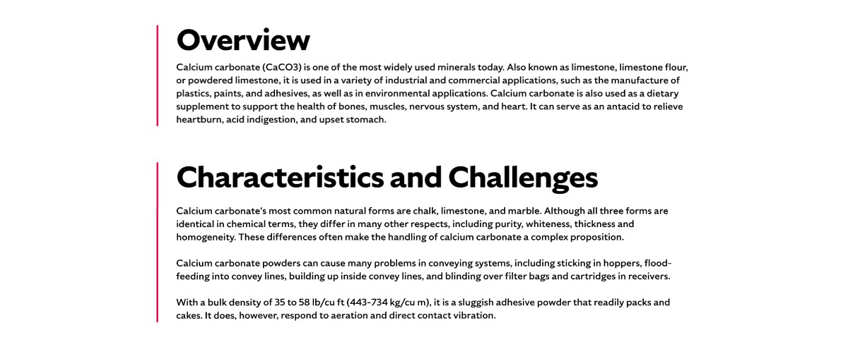

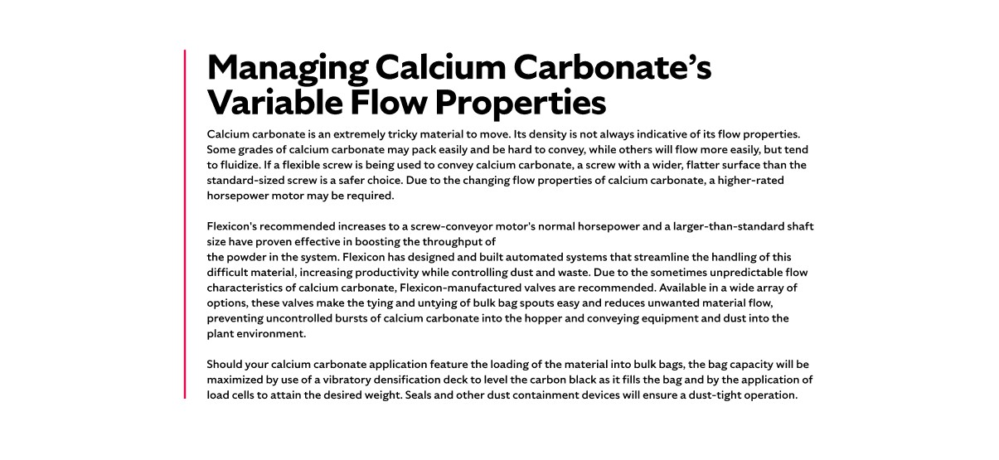

* **Overview**Milk powder comes in several types, including whole milk powder (WMP), nonfat dry milk powder (NFDM), and skimmed milk powder (SMP), each with varying levels of protein, fat, and moisture. The defining characteristics include milkfat content (ranging from 1.5% to 40% on a milk-solids-not-fat basis) and moisture content (typically below 5%). SMP and NFDM are further defined by milk protein content, with SMP requiring a minimum of 34%. Milk powders are classified by heat treatment during manufacture, which influences solubility and determines their applications. Uses range from enhancing baked goods, chocolate, and ice cream to serving as an egg substitute, freshness aid, or component in infant formula. Milk powder also plays a critical role in humanitarian relief, emergency food storage, and outdoor activities.
* **Characteristics and Challenges**Milk powders generally have a limited shelf life, with WMP remaining fresh for about six months and SMP lasting up to three years. The bulk density averages 35 lb/cu ft. Milk powder is aeratable, meaning air movement can cause it to become airborne as dust, and some types may fluidize, behaving like a liquid under certain conditions.  
  Handling milk powder requires stringent hygienic standards. In the U.S., 3-A Sanitary Standards define equipment design, materials, and installation requirements for dairy processing. Highly processed powders, especially fat-enriched types, can leave residues in convey lines, creating hygiene risks and affecting product quality. Milk powders are prone to moisture uptake, causing clumping, and fat oxidation can produce off-flavors at elevated storage temperatures. Additionally, milk powder dust can be explosive, and bulk density may vary significantly between shipments.

**SHELF #2 - FLEXICON SOLUTIONS**

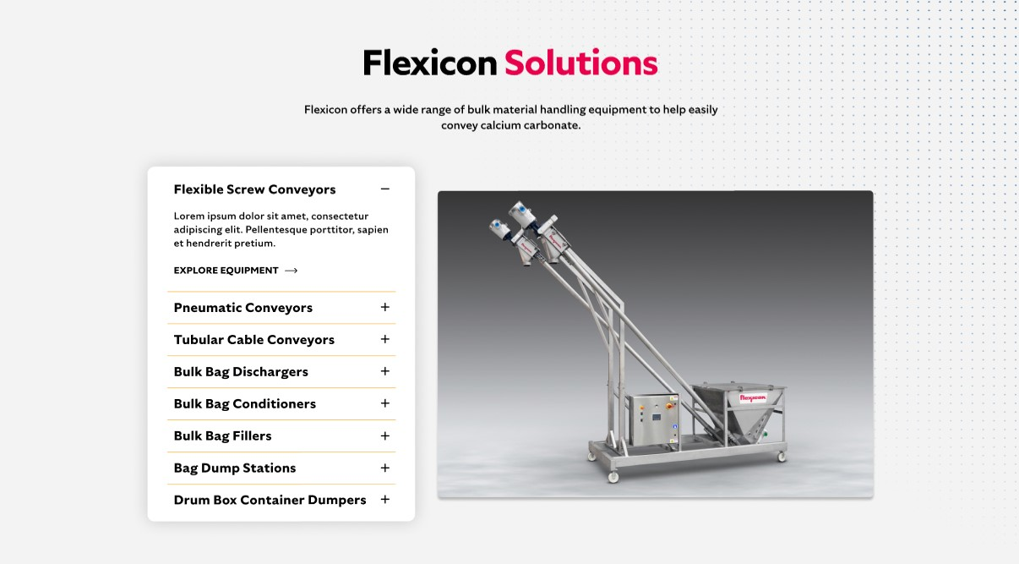

**Flexicon Solutions**

Flexicon offers a wide range of bulk material handling equipment to help easily convey calcium carbonate.

* **Flexible Screw Conveyor**: Designed to move milk powder gently, reducing product degradation while maintaining consistent flow.
* **Pneumatic Conveyors**: Transport milk powder efficiently using filtered air to contain dust and prevent contamination.
* **Tubular Cable Conveyors**: Offer low-shear, enclosed conveying for fragile or aeratable powders to minimize dust and product breakdown.
* **Bulk Bag Dischargers**: Support hygienic, complete discharge of bulk bags while containing dust and preserving product integrity.
* **Bulk Bag Conditioners**: Promote consistent flow from bulk bags by compressing and stretching bags to eliminate stagnant powder pockets.
* **Bulk Bag Fillers**: Provide accurate, sanitary filling of bulk bags while minimizing dust and maintaining product quality.
* **Bag Dump Stations**: Facilitate safe, contained unloading of small bags with dust hoods and remote dust collection.
* **Drum Box Container Dumpers**: Enable hygienic emptying of drums, boxes, and containers while controlling airborne powder.

**SHELF #3: LIFETIME PERFORMANCE GUARANTEE**

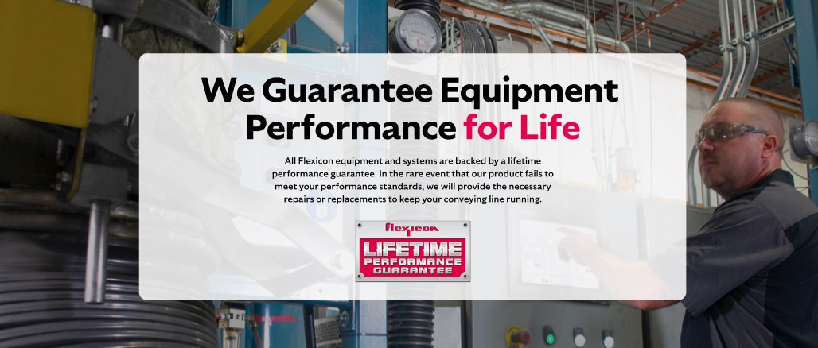

**Lifetime Performance Guarantee**

All Flexicon equipment and systems are backed by a lifetime performance guarantee. In the rare event that our product fails to meet your performance standards, we will provide the necessary repairs or replacements to keep your conveying line running.

**SHELF #4: CASE STUDIES**

